**Fiori timesheet entry Procedure**

**Step1**- Login into the sharepoint Link- <https://nttdatagroup.sharepoint.com/Pages/Welcome.aspx>

**Step 2**- Go to my links- Select- SAP Fiori Time Entry and Approval

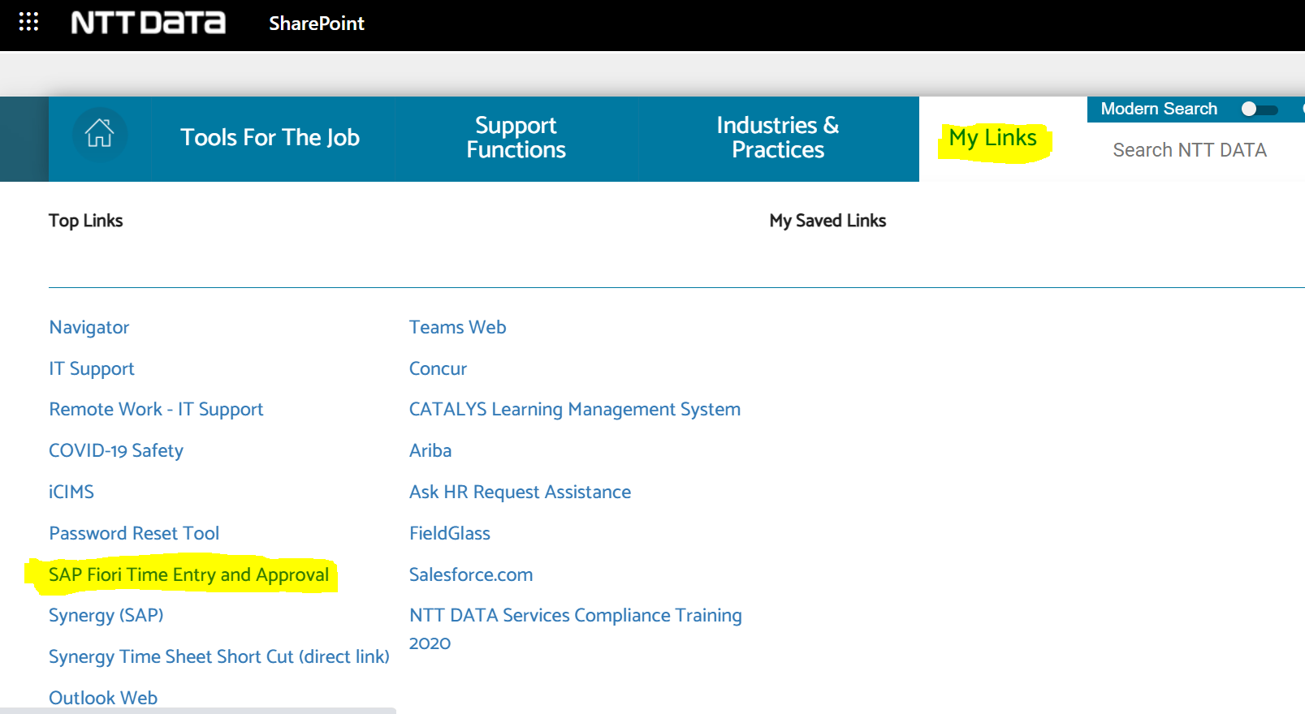

Step 3- Select -My Timesheet Record Working Time

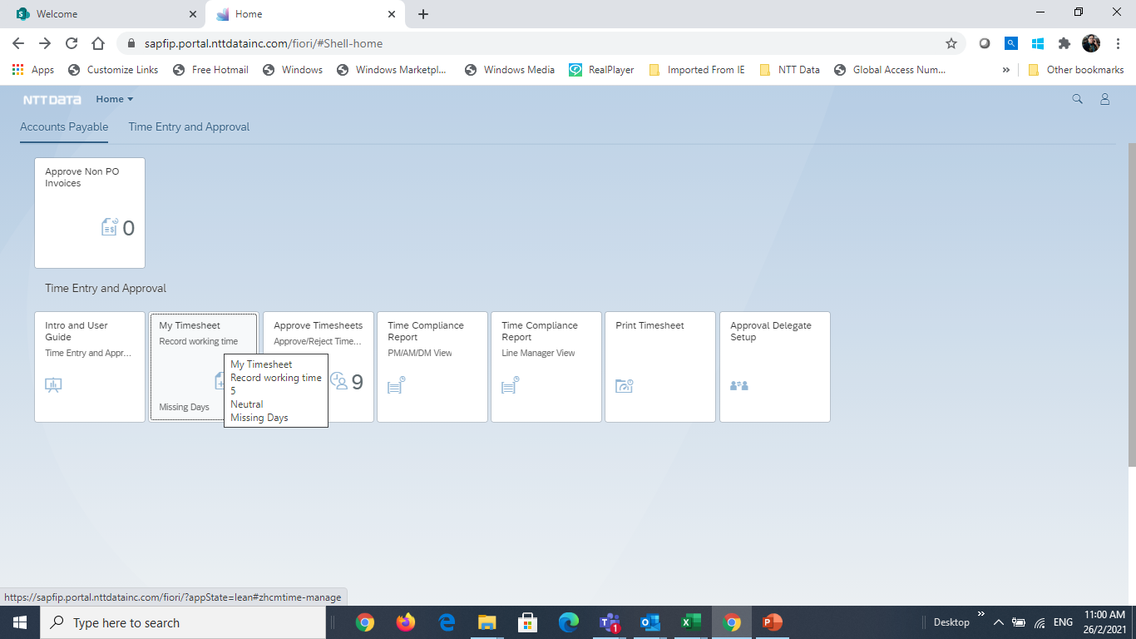

Step 4- Select – Assignments and click on Import and select worklist and select the WBS

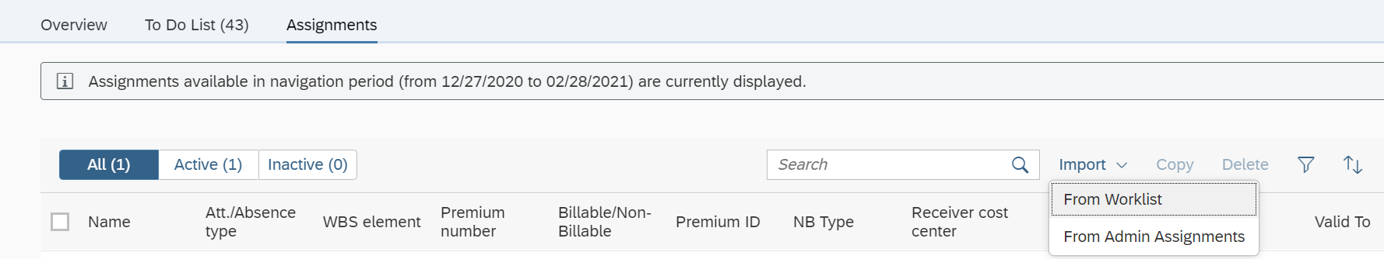

**Step 5**- Select- To Do List and then click on enter Records

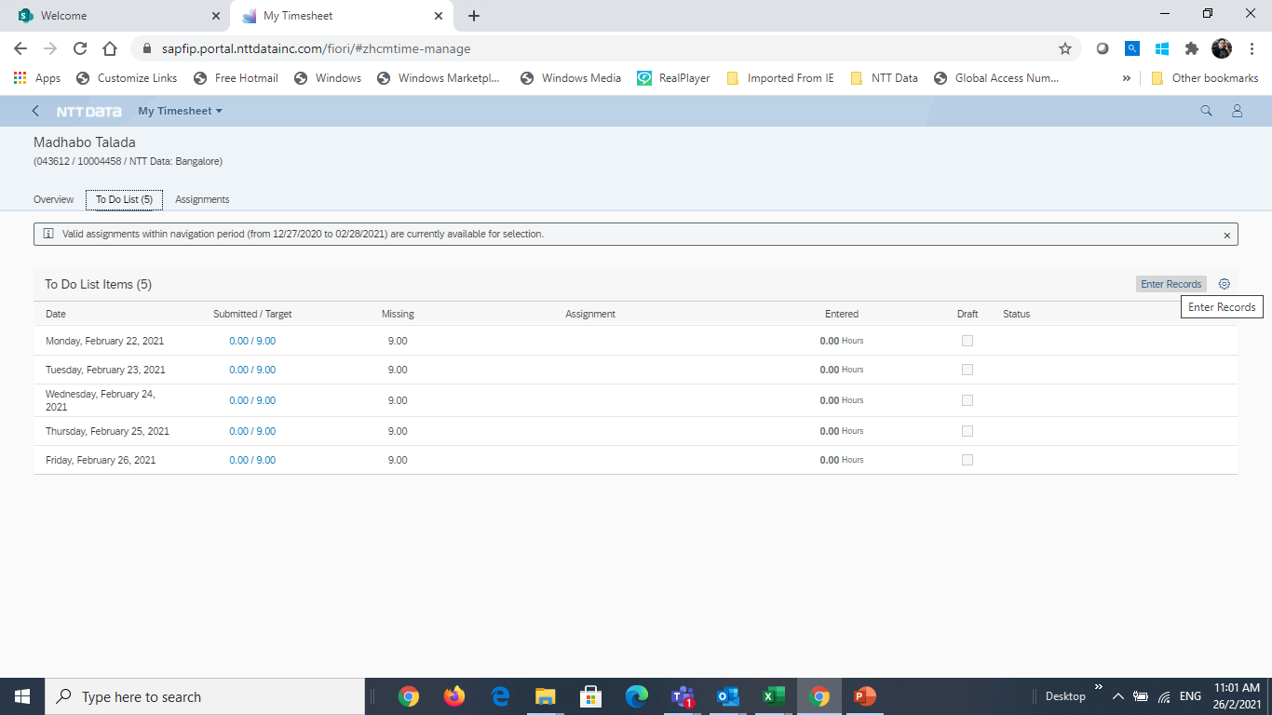

**Step 6**- after selecting Enter Records- Below screen will appear for pending date, update the working days hours as 9 and for leaves update as 0 Hours.

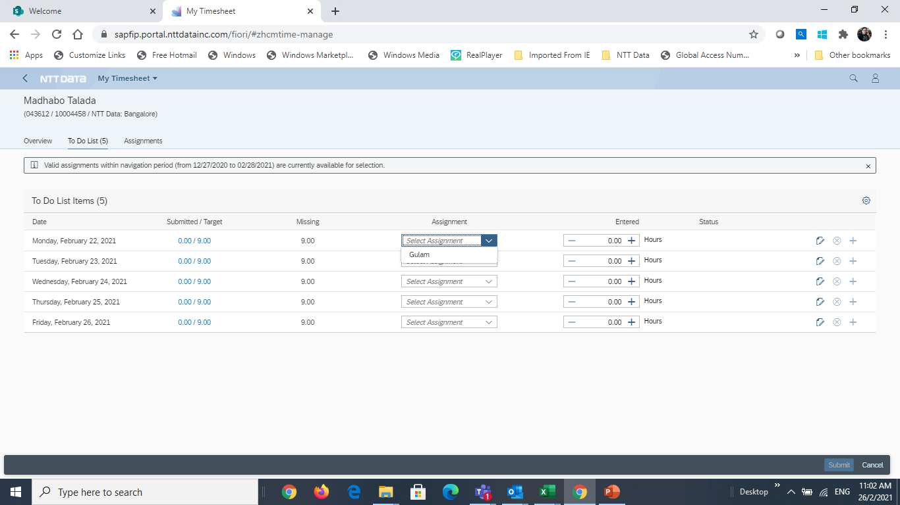

Step 7- Click on **Submit button** on the bottom.

